Battery and fuel cells

It is often considered that the battery is the main aspect that could help or hinders the development of the electric vehicle market and charging station industry. According to the Meridian International Research Cabinet, the reserves will not be enough to develop completely the electric vehicle market; other battery ions, or technologies, should be investigated. However, according to a German study from *Zentrum für Sonnenenergie-und Wasserstoff-Forschung Baden-Württemberg*, there is enough lithium on Earth to produce more than 10 billion electric vehicles, which should sufficient, because the market today is estimated at about 1 billion vehicles, and estimated to grow to 2,5 billion in 2050. USGS (US Geological Survey) institute concludes that there is a concern about this issue. Besides, the reserves of Lithium are globally located in a few countries (Bolivia, Chile, Argentina, China, United States), which could have an impact on the supply chain and the price in the future.

Lithium Reserve Base (in MM tons)

Source: *US Geological Survey, SinoLatin Capital Analysis*

Nevertheless, for the moment, due to economies of scale, better technologies, and the increasing extraction of Lithium, the price of electric vehicle battery is decreasing.

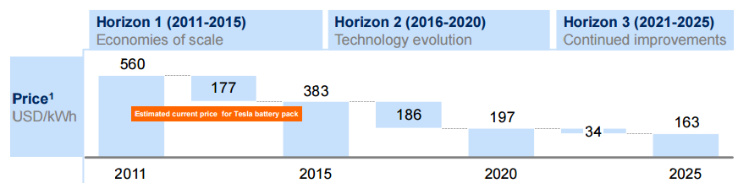

Source: Electric vehicles in Europe: gearing up for a new phase ? McKinsey

Alternatives to Lithium in the electrical vehicle market will be other ions to make batteries, or fuel cells. According to the *Union of Concerned Scientists*, both batteries and fuel cells could have a great impact on the electric vehicle market. Electric vehicle will be more used for an urban environment, whereas fuel cell vehicles will be more performant for long distance travels, or bigger cars. They are not considered as competitive, but rather as complementary technologies because they do not have the same advantages. But vehicles running with fuel cell technology will need hydrogen charging stations. When considering the charging station industry, it will mean that the electrical charging station and the hydrogen charging stations will coexist in the market, to fulfill different needs.

Quotes:

The price of electric vehicle battery is decreasing

Fuel cell technology will need hydrogen charging stations

Layar:

On Meridian International Research Cabinet : <http://www.meridian-int-res.com/Projects/Lithium_Microscope.pdf>

On from Zentrum für Sonnenenergie-und Wasserstoff-Forschung Baden-Württemberg: http://www.zsw-bw.de/en/the-zsw.html

(<http://www.themavision.fr/jcms/rw_438628/la-baisse-rapide-du-prix-des-batteries-lithium-ion-et-la-structuration-de-la-filiere>

Pie chart: <http://www.sinolatincapital.cn/sp/show_white.asp?id=264>

Graph on battery price : http://www.mckinsey.com/search.aspx?q=electric+vehicles+in+europe

References

Bethel, E., Panama, J. and Luo, S. (2010). SINOLATIN | NOTAS TÉCNICAS | THE PREMIER INVESTMENT PLATFORM BETWEEN CHINA AND LATIN AMERICA|CHINA|LATIN|ARGENTINA|BOLIVIA|BRAZIL|CHILE|COLOMBIA|ECUADOR|FREACH GUIANA|GUYANA|PARAGURY|PERU|SURINAME|URUGUARY|VENEZUELA. [online] Sinolatincapital.cn. Available at: http://www.sinolatincapital.cn/sp/show_white.asp?id=264 [Accessed 3 Jun. 2015].

Electric vehicles in Europe. (2014). 1st ed. [ebook] McKinsey. Available at: http://www.mckinsey.com/search.aspx?q=electric+vehicles+in+europe [Accessed 3 Jun. 2015].

Goonan, T. (2012). Lithium use in batteries. 1st ed. [ebook] Reston Virginia: US Geological Survey, pp.9,11. Available at: http://pubs.usgs.gov/circ/1371/pdf/circ1371_508.pdf [Accessed 3 Jun. 2015].

Lamire, F. (2015). themavision.fr - La baisse rapide du prix des batteries Lithium Ion et la structuration de la filière. [online] Themavision.fr. Available at: http://www.themavision.fr/jcms/rw_438628/la-baisse-rapide-du-prix-des-batteries-lithium-ion-et-la-structuration-de-la-filiere [Accessed 3 Jun. 2015].

The importance of both battery electric and hydrogen fuel cell electric vehicles. (2014). 1st ed. [ebook] Available at: http://www.ucsusa.org/sites/default/files/attach/2014/11/importance-bev-hfcev-fact-sheet.pdf [Accessed 3 Jun. 2015].

The trouble with Lithium. (2008). 2nd ed. [ebook] Martainville: Meridian International Research. Available at: http://www.meridian-int-res.com/Projects/Lithium_Microscope.pdf [Accessed 3 Jun. 2015].

Zsw-bw.de, (2015). ZSW: Startseite. [online] Available at: http://www.zsw-bw.de/ [Accessed 3 Jun. 2015].